F Y B Tech SEM I 2021-22

Engineering Physics Lab Course

**Experiment No.: 1**

**Title: Photoelectric effect**

**Name: Eshan Kalp Trivedi**

**Roll No: 16010221038**

**Branch: ETRX**

**Batch: D2**

**Aim:**

1. To understand the phenomenon Photoelectric effect as a whole.
2. To plot a graph connecting photocurrent and applied potential.
3. To determine the stopping potential from the photocurrent versus applied potential graph.

**Apparatus:**

Voltmeter, Ammeter, Rheostat, Battery, Lightsource, Anode Material

**Diagram:**

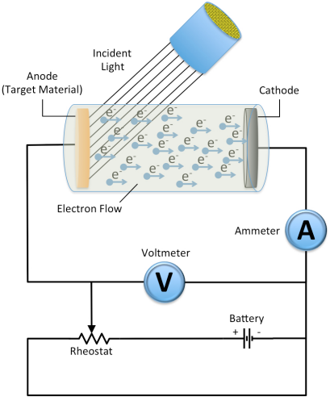

**Observation Table:**

**PART I: Fixed wavelength, varying intensity:**

|  |  |  |  |  |  |
| --- | --- | --- | --- | --- | --- |
| Wavelength: 146 nm (threshold wavelength = 500 - 600nm) | | | | | |
| Intensity = 15 W/m2 | | Intensity = 20 W/m2 | | Intensity = 25 W/m2 | |
| Voltage (V) | Current (µA) | Voltage (V) | Current (µA) | Voltage (V) | Current (µA) |
| 0 | 46.68 | 0 | 62.24 | 0 | 77.8 |
| -1 | 39.18 | -1 | 52.24 | -1 | 65.30 |
| -1.9 | 32.43 | -1.9 | 43.24 | -1.9 | 54.05 |
| -2.5 | 27.93 | -2.5 | 37.24 | -2.5 | 46.55 |
| -3.2 | 22.68 | -3.2 | 30.24 | -3.2 | 37.80 |
| -4.3 | 14.43 | -4.3 | 19.24 | -4.3 | 24.05 |
| -5.1 | 8.43 | -5.1 | 11.24 | -5.1 | 14.05 |
| -5.6 | 4.68 | -5.6 | 6.24 | -5.6 | 7.80 |
| -6.1 | 0.93 | -6.1 | 1.24 | -6.1 | 1.55 |
| -6.3 | 0.0 | -6.3 | 0.0 | -6.3 | 0.0 |

**PART II: Fixed intensity, varying wavelength:**

|  |  |  |  |  |  |
| --- | --- | --- | --- | --- | --- |
| Intensity: 30 W/m2 | | | | | |
| Wavelength = 200 nm | | Wavelength = 300 nm | | Wavelength = 400 nm | |
| Voltage (V) | Current (µA) | Voltage (V) | Current (µA) | Voltage (V) | Current (µA) |
| 0 | 58.92 | 0 | 27.88 | 0 | 12.36 |
| -0.5 | 51.42 | -0.1 | 26.38 | -0.1 | 10.86 |
| -1.2 | 40.92 | -0.4 | 21.88 | -0.2 | 9.36 |
| -1.7 | 33.42 | -0.7 | 17.38 | -0.3 | 7.86 |
| -2.4 | 22.92 | -0.8 | 15.88 | -0.4 | 6.36 |
| -2.9 | 15.42 | -1.0 | 12.88 | -0.5 | 4.86 |
| -3.3 | 9.42 | -1.3 | 8.38 | -0.6 | 3.36 |
| -3.5 | 6.42 | -1.5 | 5.38 | -0.7 | 1.86 |
| -3.8 | 1.92 | -1.8 | 0.88 | -0.8 | 0.36 |
| -4 | 0 | -1.9 | 0 | -0.9 | 0 |

**Graphs*:**

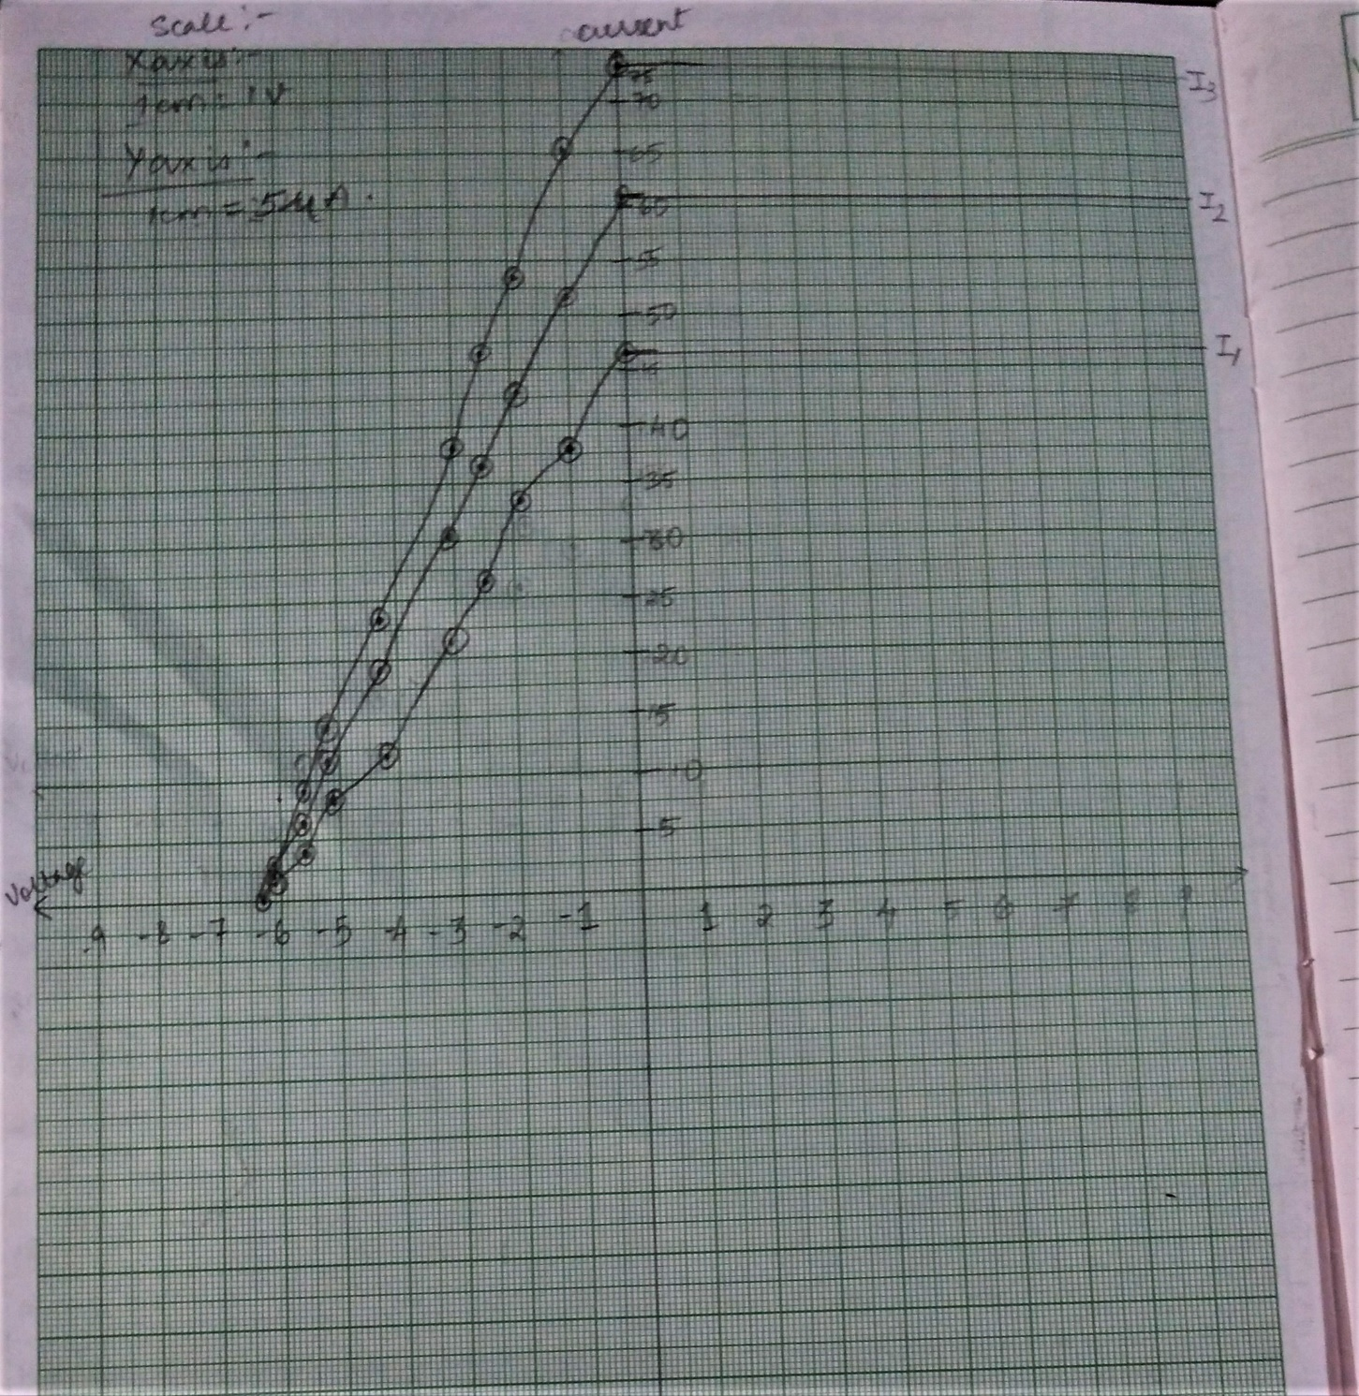

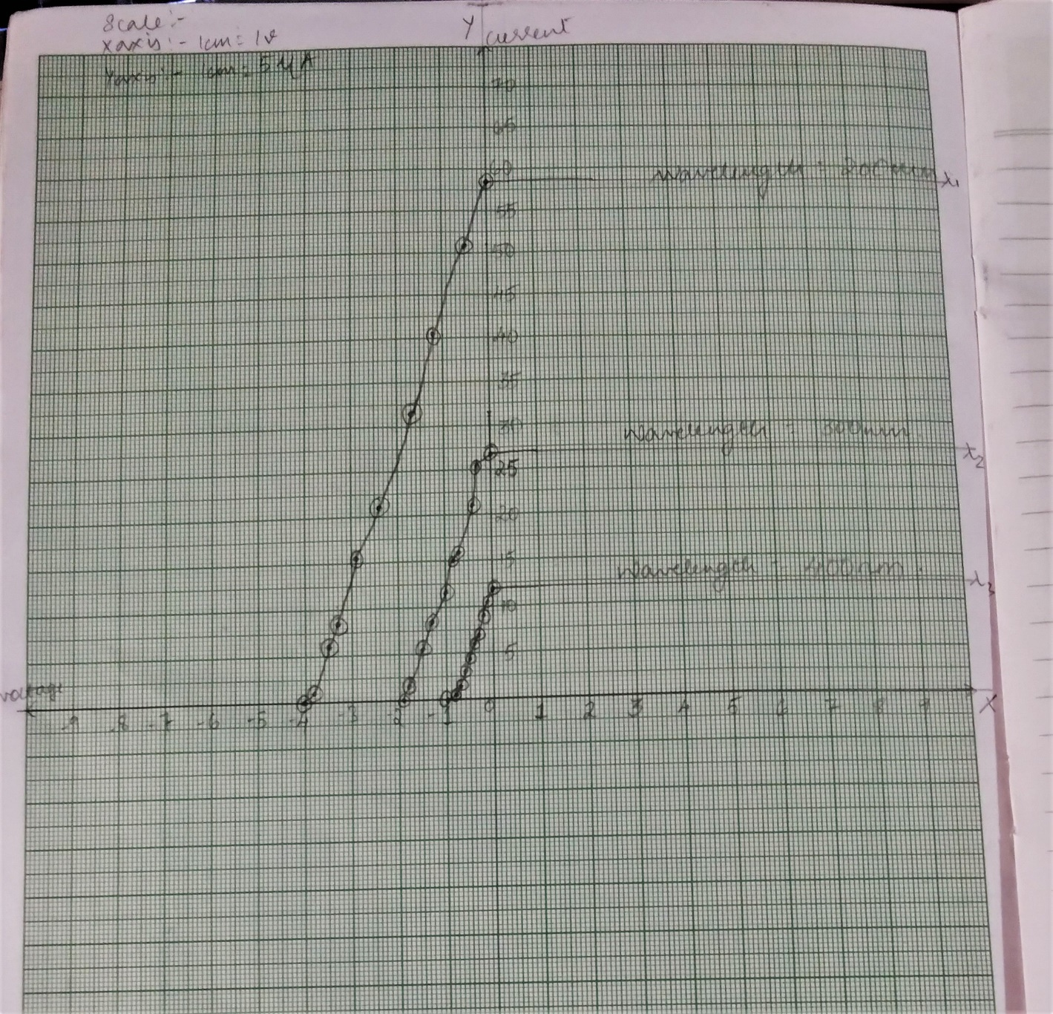

**Calculations:**

**Results:** From the plotted graphs we can determine that stopping potential is -6.3 V

**Link for home assignment uploaded:**

**HOME ASSIGNMENT**

Material: Zinc Area of plates: 0.5 cm2

**PART I: Fixed wavelength, varying intensity:**

|  |  |  |  |  |  |
| --- | --- | --- | --- | --- | --- |
| Wavelength: 146 nm (threshold wavelength = 500 - 600nm) | | | | | |
| Intensity = 15 W/m2 | | Intensity = 20 W/m2 | | Intensity = 25 W/m2 | |
| Voltage (V) | Current (µA) | Voltage (V) | Current (µA) | Voltage (V) | Current (µA) |
| 0 | 31.53 | 0 | 42.04 | 0 | 52.55 |
| -0.7 | 26.28 | -0.7 | 35.04 | -0.7 | 43.80 |
| -1.2 | 22.53 | -1.2 | 30.04 | -1.2 | 37.55 |
| -1.6 | 19.53 | -1.6 | 26.04 | -1.6 | 32.55 |
| -2.1 | 15.78 | -2.1 | 21.04 | -2.1 | 26.30 |
| -2.5 | 12.78 | -2.5 | 17.04 | -2.6 | 20.05 |
| -3.4 | 6.03 | -3.4 | 8.04 | -3.3 | 11.30 |
| -3.9 | 2.28 | -3.8 | 4.04 | -3.8 | 5.05 |
| -4.1 | 0.78 | -4.1 | 1.04 | -4.1 | 1.30 |
| -4.3 | 0.0 | -4.3 | 0.0 | -4.3 | 0.0 |

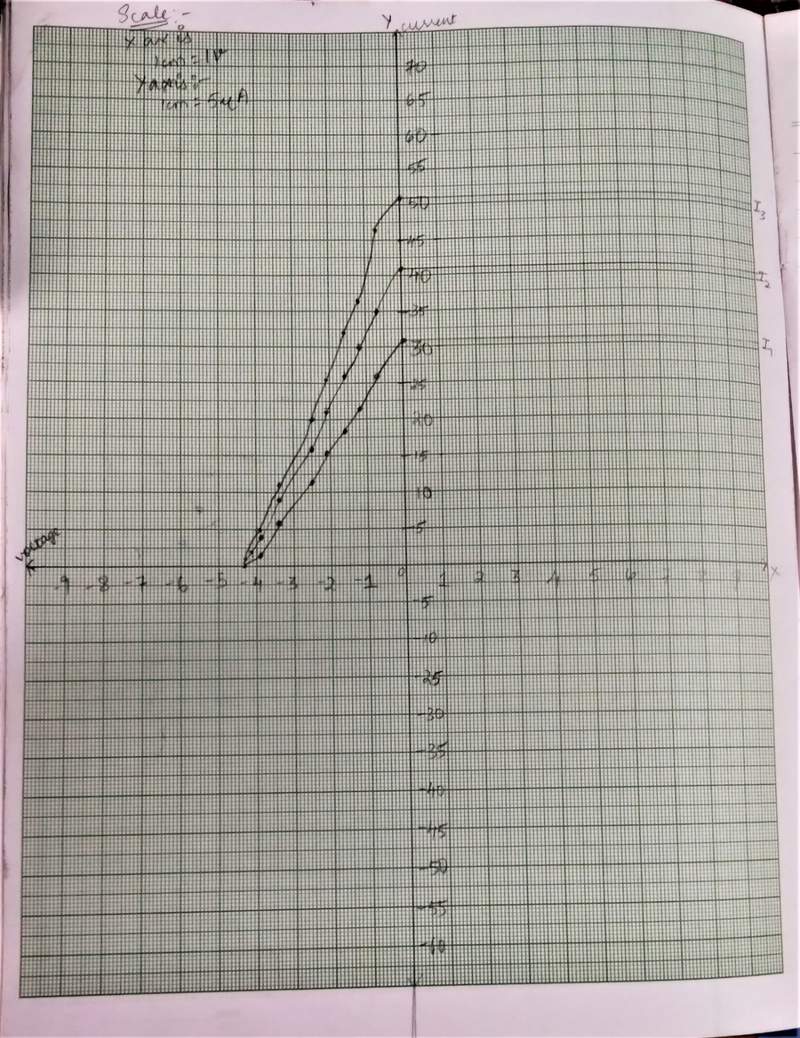

**PART II: Fixed intensity, varying wavelength:**

|  |  |  |  |  |  |
| --- | --- | --- | --- | --- | --- |
| Intensity: 30 W/m2 | | | | | |
| Wavelength = 120 nm | | Wavelength = 150 nm | | Wavelength = 200 nm | |
| Voltage (V) | Current (µA) | Voltage (V) | Current (µA) | Voltage (V) | Current (µA) |
| 0 | 90.70 | 0 | 59.66 | 0 | 28.62 |
| -0.7 | 80.20 | -0.7 | 49.16 | -0.2 | 25.62 |
| -1.4 | 69.70 | -1.3 | 40.16 | -0.4 | 22.62 |
| -2.1 | 59.20 | -1.8 | 32.66 | -0.5 | 21.12 |
| -2.8 | 48.70 | -2.3 | 25.16 | -0.8 | 16.62 |
| -3.5 | 38.20 | -2.8 | 17.66 | -0.9 | 15.12 |
| -4.7 | 20.20 | -3.1 | 13.16 | -1.2 | 10.62 |
| -5.2 | 12.70 | -3.5 | 7.16 | -1.5 | 6.12 |
| -5.9 | 2.20 | -3.8 | 2.66 | -1.8 | 1.62 |
| -6.1 | 0 | -4.0 | 0 | -2.0 | 0 |

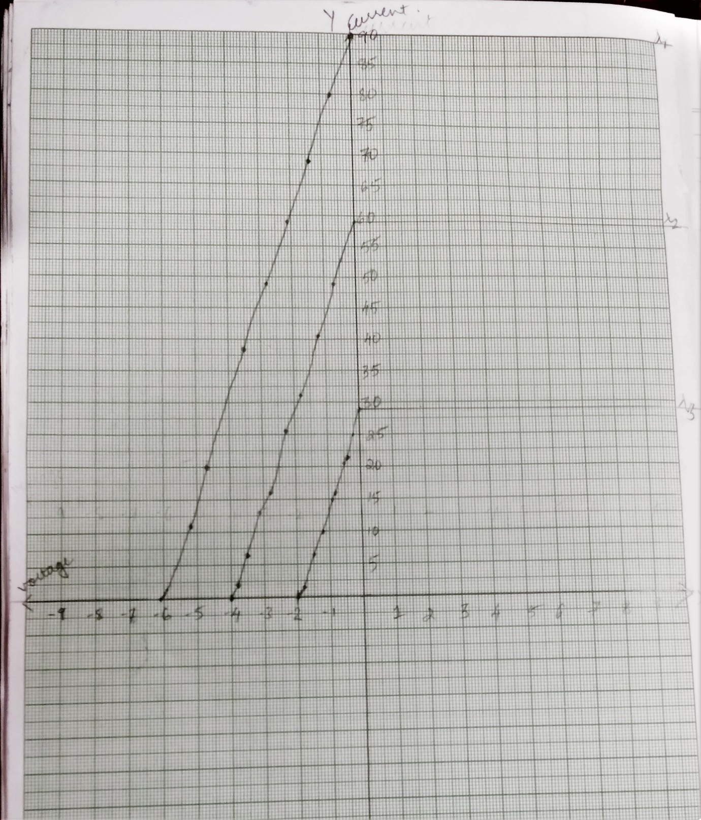

**Result :** From the plotted graphs we can determine that stopping potential is -4.3 V